
a
Company
Logotype

Cone Beam Computed Tomography- Report



Porur Dental X-rays & CBCT

Patient Name : Mr. Karuppasamy | Date of Report : 26.11.2024
Age/ Gender : 52 years/ Male | Region of Interest : CBCT Maxilla
Referring doctor: Dr. Karthik. K | Indication : Assessment of Maxillary sinus
Clinical Notes: Nil
PATIENT INFORMATION

CBCT- Maxilla provided
CBCT – IMAGE DETAILS

RADIOGRAPHIC INTERPRETATION

- The maxillary alveolar ridge is present with normal trabecular pattern.
- The right maxillary sinus is present with a hyperdense structure along the floor of the sinus without a surrounding area of mucosal thickening along the floor and the anterior wall of the sinus.
- The hyperdense structure within the right maxillary sinus measures 6.61 x 1.47 x 3.66mm in dimension.
- The left maxillary sinus is present with mucosal thickening along the floor, medial wall and lateral wall.
- The roots of the posterior teeth in the right and left side appear project anatomically into the maxillary sinus and lie in close apposition to the floor of the sinus.
- Both the maxillary sinuses are present with antral septae-
- Right Maxillary sinus: Medial wall, Lateral wall.
- Left Maxillary sinus: Roof of the sinus, Medial wall.

RADIOGRAPHIC IMPRESSION

- Bilateral maxillary sinusitis.
- Linear Intra-Sinus calcification: right maxillary sinus.

Kindly correlate with clinical findings


IMAGES FOR REFERENCE

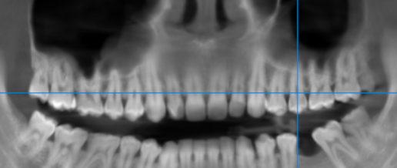

Right maxillary sinus

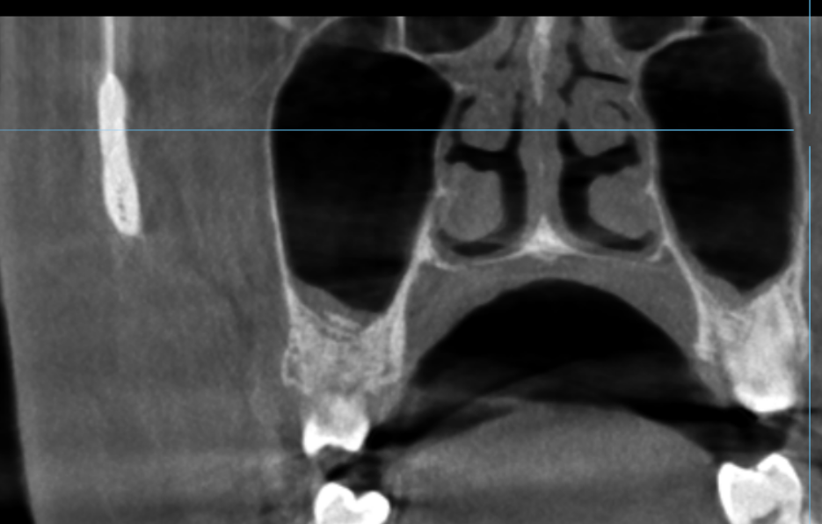

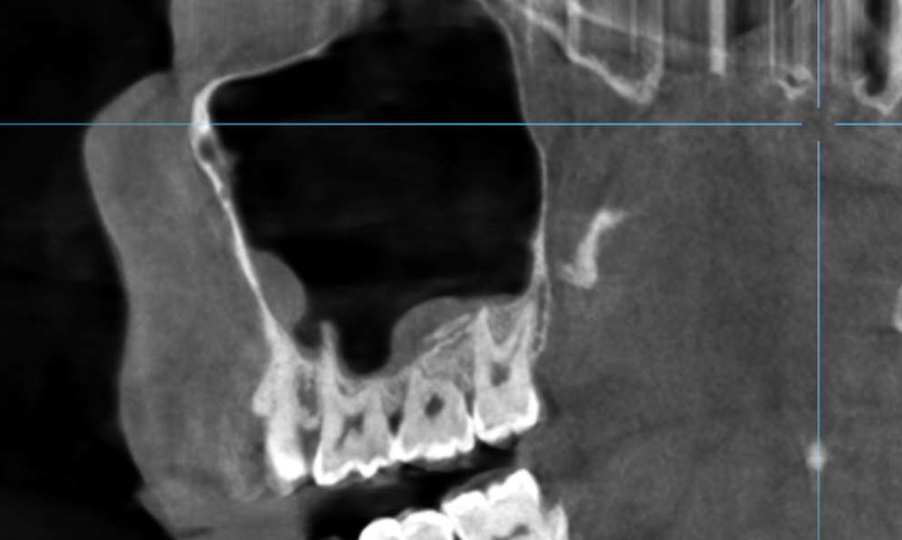

Left maxillary sinus
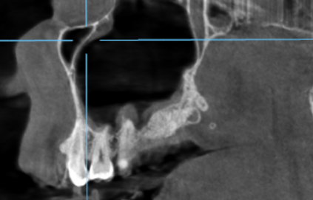
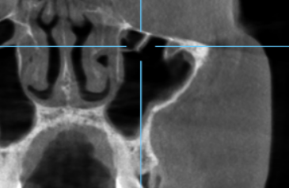

3-DIMENSIONAL VIEW
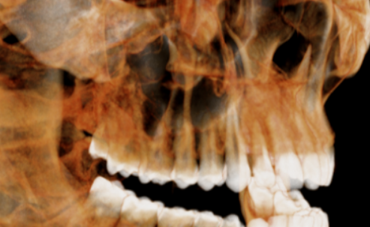

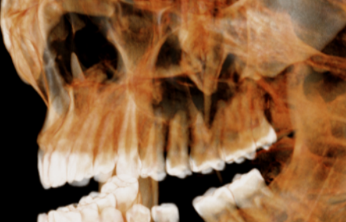

**** End of report ****

